URL： <http://lab05slian.azurewebsites.net/tables/Mountain?zumo-api-version=2.0.0>

GitHub URL:

1. **Create a spinning cube for each Mountain**

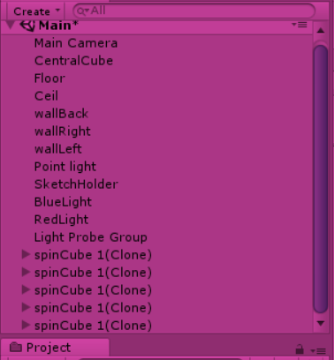

1. **Attach the MountainName to it**

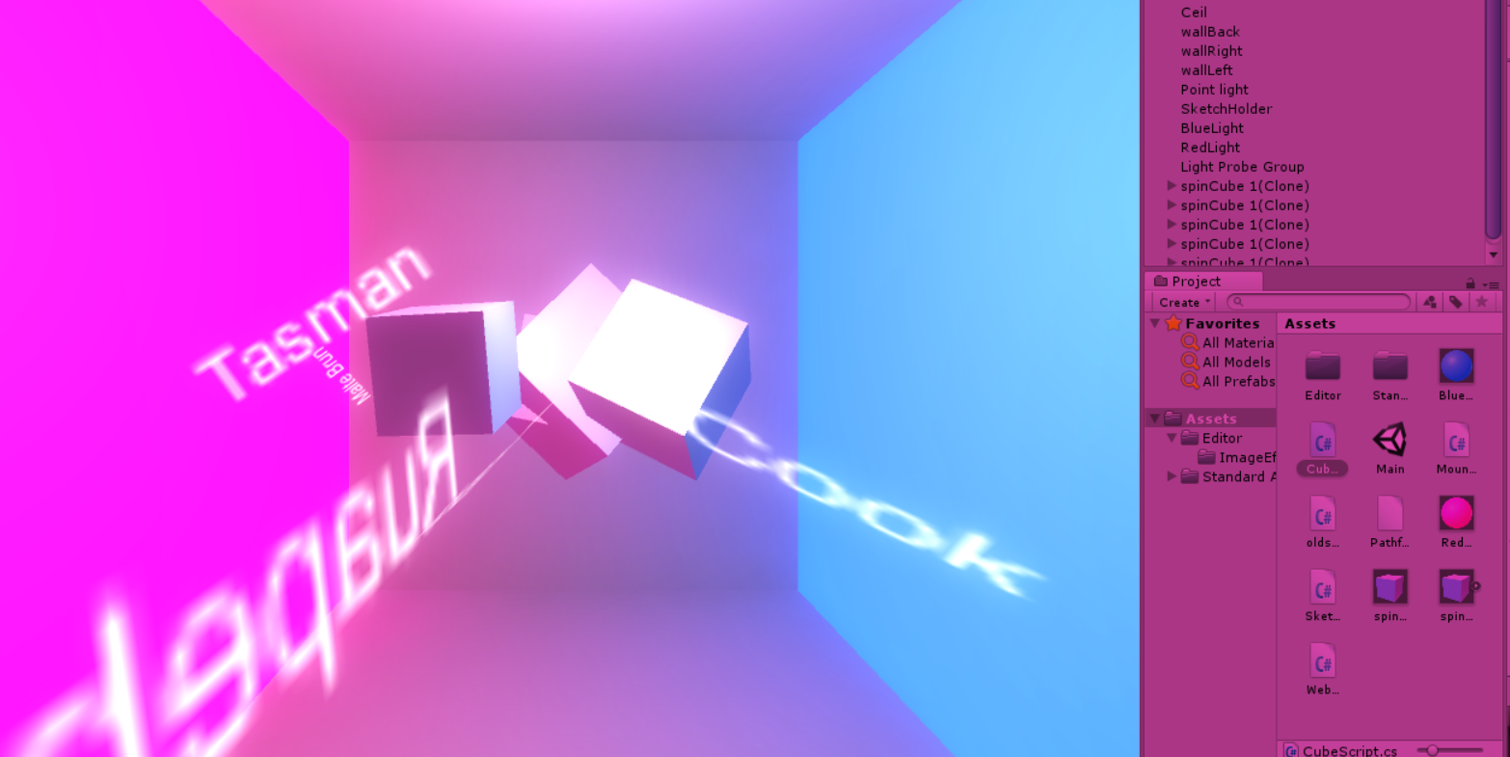

1. **Place Cubes at their X, Y, Z coordinates**

The coding part:

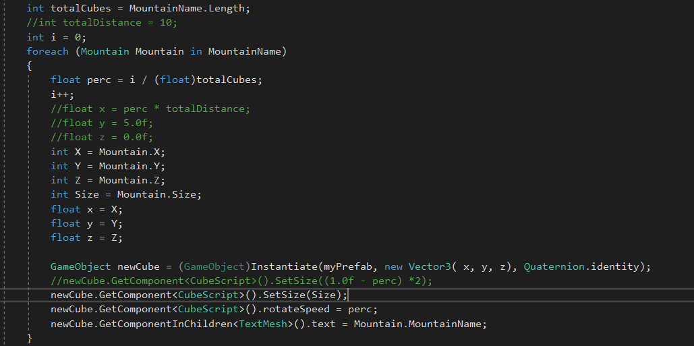

Cube one:

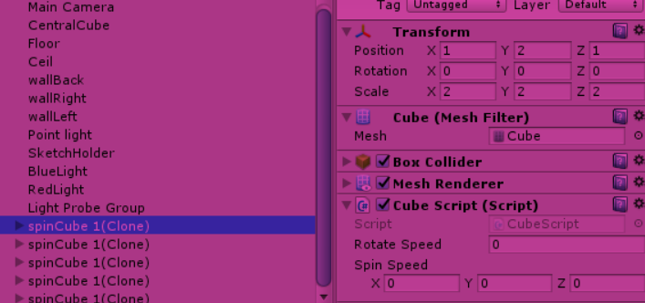

Cube Two:

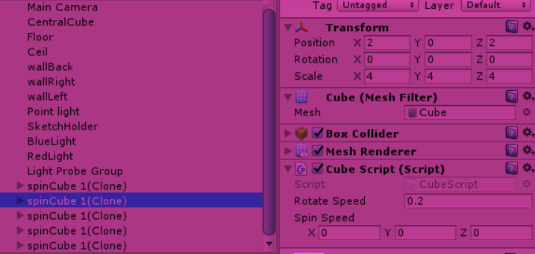

Cube Three:

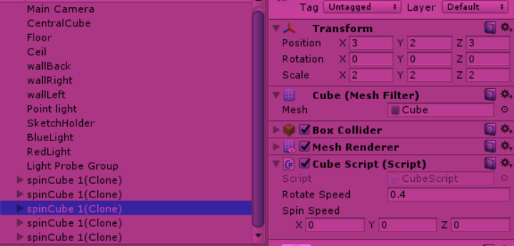

Cube Four:

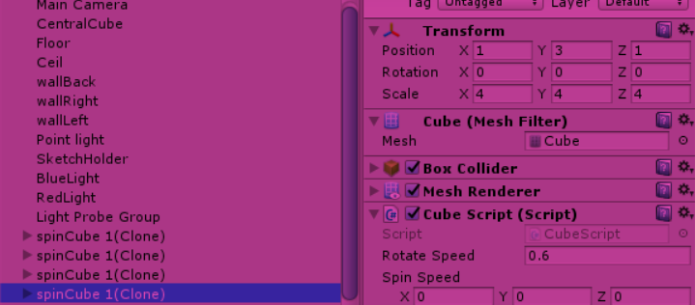

Cube Five:

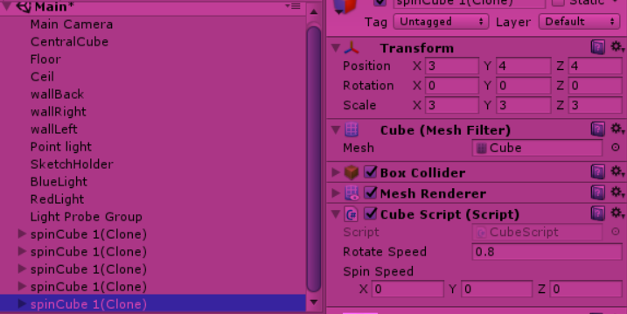

1. **Stop them spinning**

By commenting out the spin function:

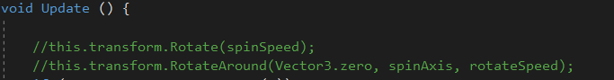

**Set the size of each cube**

Already set from q3:

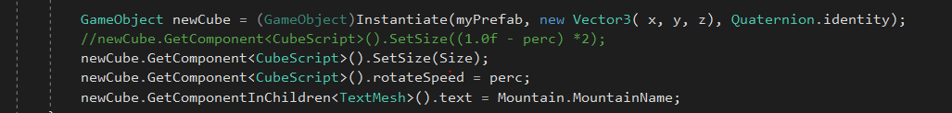

**Set Prefab based on Symbol value**

**Cube 1 and 3 are Spheres:**

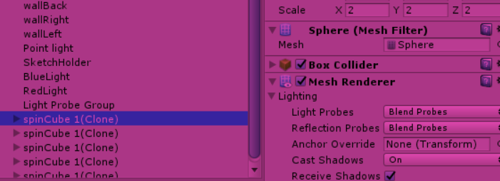

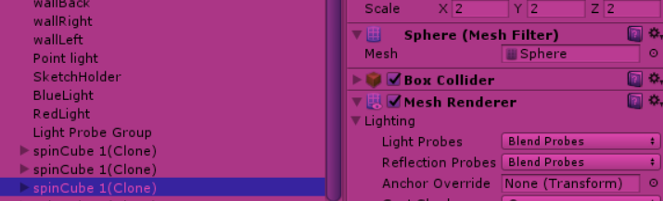

1. **Set a breakpoint and examine values in array of Mountains**

